1. Write Select statements to retrieve data from the instructor and student tables in university Database.

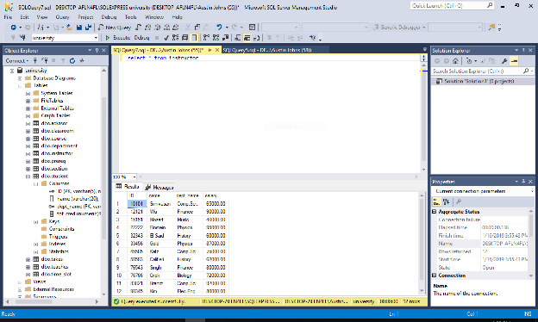

1. Write query statements that Insert records into instructor and student.

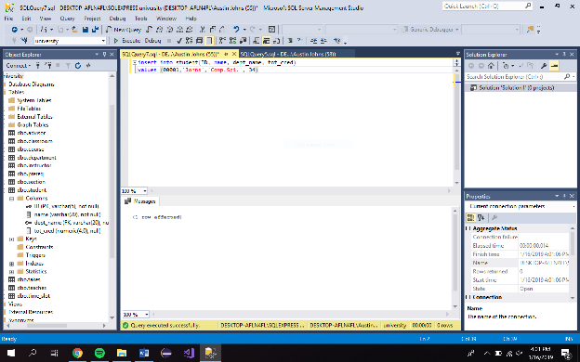

1. Update your new record records in instructor and student.

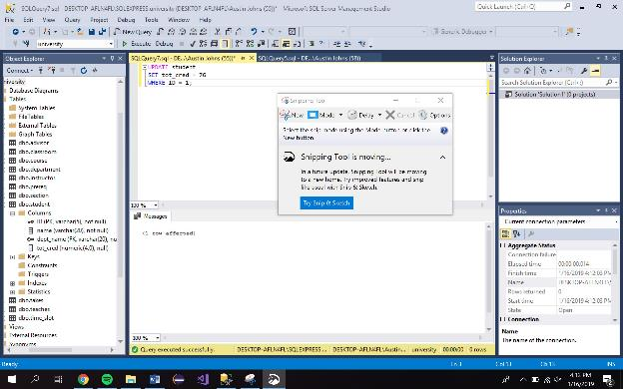

1. Delete your new records from instructor and student.

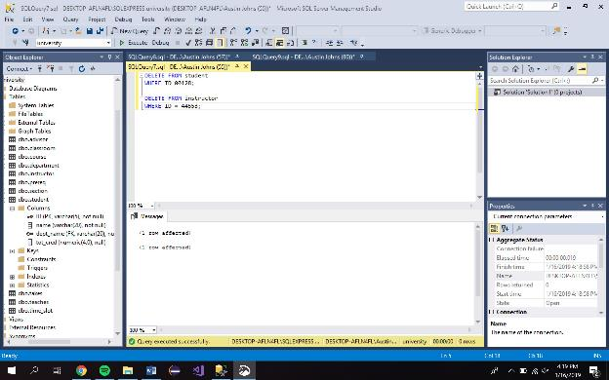

1. Join tables to retrieve data.

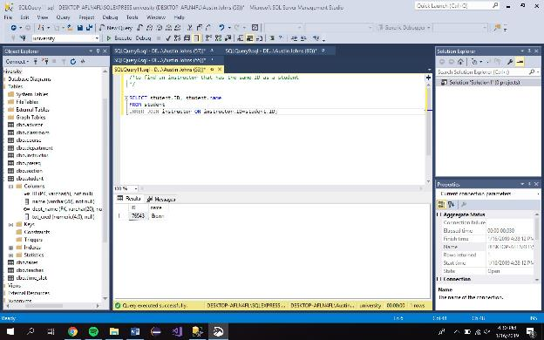

1. Create new tables with joined data.

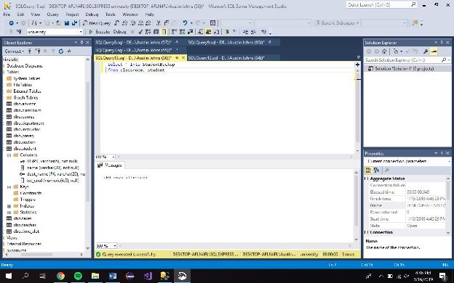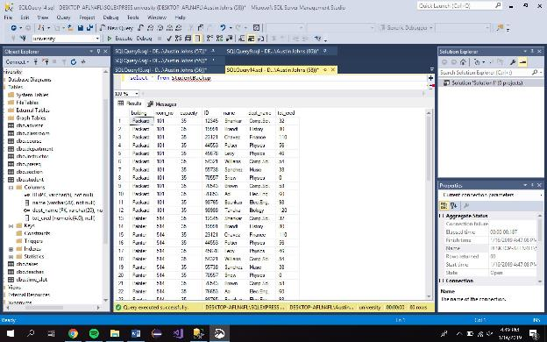

1. Drop newly created tables from database.

